Plant Leaf Disease Detection Using Mobilenetv2

Devvret Verma¹, Dibyahash Bordoloi², Vikas Tripathi³

¹Department of Biotechnology,Graphic Era Deemed to be University, Dehradun, Uttarakhand India, 248002
²Head of the Department, Department of Computer Science & Engineering,Graphic Era Hill University, Dehradun, Uttarakhand India, 248002
³Department of Computer Science & Engineering,Graphic Era Deemed to be University, Dehradun, Uttarakhand India, 248002

ABSTRACT
Identifying plant diseases early is crucial because they effect the development of affected plants. Despite the fact that a wide variety of ML models have already been put to use in plant disease detection and classification, the recent developments in a branch of ML known as Deep Learning (DL) have given this area of research a lot of hope for improved precision. On the other hand, there is currently no reliable and quick disease detector that can be used to guarantee a plant's healthy growth and development. In this paper we proposed a deep learning model to detect plant leaf disease using MobileNetV2 model. The approach depends on a inverted residual structure, with the connections between the thin bottleneck layers serving as the shortcuts. To introduce some non- linearity into the intermediate expansion layer, we filter features using light-weight depthwise convolutions. From experimental analysis, it is seen that plant leaf disease detection using MobileNetV2 outperforms existing approach in terms of accuracy as well as training time.

Keywords: Deep Learning, Plant leaf disease classification, MobileNet, Image classification

INTRODUCTION
The detection of plant diseases is a significant obstacle for the agricultural industry. The symptoms are clearly visible on the leaf of some of the plants. Diseases can be identified by their strange leaf patterns, and swift action taken to stop their spread. Many plant diseases are invisible to the naked eye, making accurate diagnosis a challenge even for experts. Plant diseases have traditionally been diagnosed through expert visual inspection. However, mistakes can occur because of differences in opinion. Several spectroscopic and imaging methods have been investigated for use in this setting. However, they call for sophisticated equipment and large sensors, which drives up the price and reduces the effectiveness. As digital cameras and other electronic tools have become increasingly commonplace, automatic plant disease diagnosis using machine learning has emerged as a viable alternative.
Many studies have been conducted to develop machine learning and deep learning models for disease detection in plant leaves. The authors of this study recommend using a deep learning model

to categorise plant diseases. Common machine learning models require human intervention to extract features before the algorithm can learn. There are therefore two stages to this procedure. In order to make intelligent decisions on its own, the deep learning model employs an artificial neural network that can learn features from an input image. Consequently, deep learning models excel at image-based classification in comparison to traditional machine learning models. In this paper, we have used MobileNetV2 for detecting leaf disease

RELATED STUDY
The ability to diagnose plant illnesses based solely on digital images of the plants' leaves is currently one of the most significant challenges facing precision agriculture. The advancement of artificial intelligence, image processing, and graphical processing units has the potential to make plant protection and cultivation more accurate (GPUs). Due of the diversity of plant illnesses, learning models need to be able to observe their environments and pick out the telltale signs of sickness. In order to accomplish this, one needs to be aware of the specific symptoms that are associated with any condition. Identifying and categorising plant diseases today makes use of a number of different technologies involving artificial intelligence. K-nearest neighbours, logistic regression, decision tree, support vector machine, and deep convolutional neural networks are the most frequent methodologies. Deep convolutional neural networks are also widely used (Deep CNN). In order to improve feature extraction, these strategies are often combined with a wide range of image pre- processing techniques. K-Nearest Neighbors (K-NN) is a simple memory-based method for sorting information into groups based on how much it looks like other information[1]. It was utilised to identify unlabeled things by making use of identified objects in the immediate vicinity. One form of supervised learning is the decision tree. The tree's nodes stand in for decision criteria, its branches represent possible actions based on those criteria, and its leaves are the classes.
Many important theoretical and practical accomplishments in computer vision related to deep learning and convolutional networks have been reported in recent years [2]. CNNs have been a focus of research in the field of object detection [3] due to its ability to extract features automatically and directly from the input images. This ability allows CNNs to avoid the need for sophisticated image preprocessing. Research and applications of convolutional neural networks (CNNs) are becoming increasingly common in crop disease diagnosis [4]. This trend was inspired by the achievements of CNNs in object detection. In order for the Deep CNN to get better results, it needs a lot of training data. When there is insufficient data from which to train a Deep CNN Model, picture augmentation is often used to boost the model's accuracy. Flipping, gamma correction, noise injection, principal component analysis (PCA), colour augmentation, rotation, and scaling are only some of the image processing techniques used in image augmentation to create fictitious training images[5]. In [6], the authors wrote about the best traditional ways to find plant diseases. Methods for finding plant diseases include those that use spectroscopy, imaging, and volatile profiling. In the paper, the pros and cons of each method are compared.

PROPOSED METHOD
The following properties of plant lead make it challenging to implement real-time detection of apple leaf diseases. First, a single leaf might have many illnesses at once. In addition, different diseases and instances of the same disease result in spots of varying sizes on the leaves. Also, the spots

caused by apple leaf diseases are typically quite little. Last but not least, apple leaf disease detection is hampered by environmental conditions like shadow, illumination, and soil. In this study, we employ the most recent deep learning approach, which is based on upgraded convolutional neural networks, specifically MobilNetV2, to perform real-time detection of plant leaf illnesses. Specifically, we are interested in detecting bacterial and fungal infections. This will help us overcome the issues that we have been discussing.

MOBILENETV2 MODEL
To improve accuracy, MobileNetV1 is modelled after the classic VGG architecture. This involves building a network by stacking convolution layers. However, if there are too many convolution layers in a stack, gradient vanishing becomes an issue. ResNet's residual block facilitates interlayer communication by, among other things, allowing for feature reuse during forward propagation and reducing gradient vanishing during back propagation. Therefore, MobileNetV2 utilises ResNet's residual structure in addition to the depth separable convolution that it inherited from MobileNetV1.
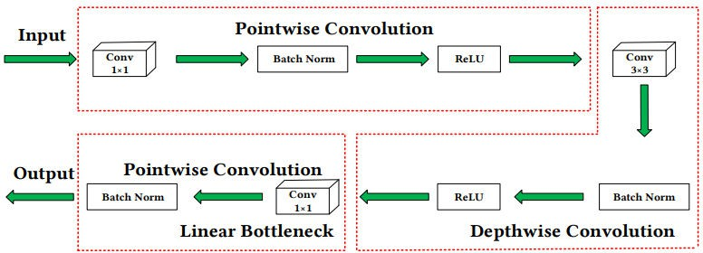
Figure 1: Inverted Residual Linear Bottleneck
The network now uses a linear bottleneck and a residual block with its inversion being the most notable difference between MobileNetV1 and MobileNetV2. As can be seen in Figure 1, MobileNetV2 makes use of an inverted residual and a linear bottleneck within a depth separable convolution block. The depthwise convolutional layer's downsampling parameter is tweaked, and a 1x1 convolution layer is stacked on top of the depthwise convolutional layer. As an alternative to a nonlinear activation function, a linear activation is employed. The network consists of 19 layers, the middle of which is responsible for feature extraction and the lowest for classification. MobileNetV1's primary structure, depthwise separable convolution, has the effects of decreasing the network parameters and increasing the network speed. Although depthwise separable convolution produces the same output dimension as regular convolution, it splits regular convolution into a 3 x 3 depthwise convolution and an 1 x 1 pointwise convolution.

By combining the information from several channels into a single one, depth-wise convolution can drastically cut down on computation time and the number of parameters needed to describe an image. However, the final output data will not be related to any of the input channels because of the convolutional method's poor channel-to-channel information transmission. By applying a pointwise

convolution, a special type of 1 x 1 convolution, to the result of a depthwise convolution, a linear combination can be generated. It is typical practise to use pointwise convolution to adjust the feature dimension of the output channel, as demonstrated in Figure 3, which can be viewed here. When compared to depthwise and group convolution, pointwise convolution is analogous to mixing information between channels. This can efficiently handle the issue of poor flow of information between channels, which is caused by convolution methods such as depthwise and group convolution.

EXPERIMENTAL ANALYSIS
The deep CNN model that was constructed utilised the dataset of plant leaf diseases for both the training and the testing phases of its development. The dataset was separated into three sets: the training set, the validation set, and the testing set. The training set contained 55,636 images, while the validation set contained 3900 images, and the testing set contained 1950 images. These pictures have been annotated with 39 different classifications, ranging from healthy to damaged plant leaves. The data samples are shown in Figure 2.
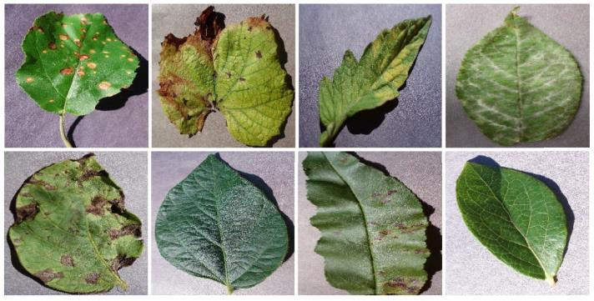
Figure 2: Dataset Sample
Both the precision of the training data and the validation data quickly converge toward a high asymptote. MobileNetV2 also achieves higher levels of accuracy with less effort and requires less time to train than MobileNetV1 did. Although proposed model is slightly less accurate than InceptionV3, it allows for faster training and maintains a fair balance between the two competing priorities of speed and precision. In comparison to MobileNetV1, MobileNetV2 has the fewest amount of parameters overall. Despite this, it is still a more effective algorithm, despite the fact that there are more trainable parameters in both rounds of the training process. This demonstrates that MobileNetV2 has a structure that is more effective than MobileNetV1. Training accuracy and loss of all models are shown in Figure 3.

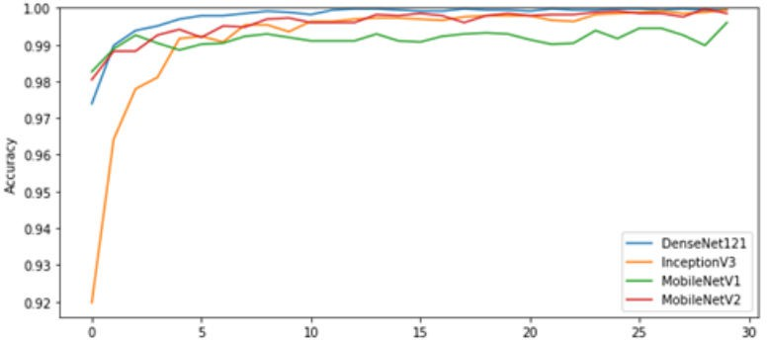
Figure 3: Training Accuracy
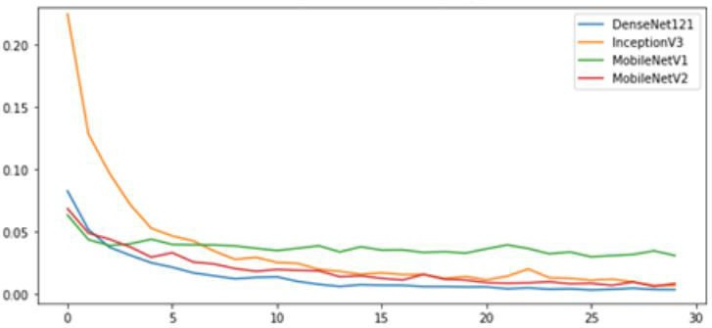
Figure 4: Training Loss
Model | Accuracy | Running Time(s)
MobileNetV1 | 99.4% | 317.49
MobileNetV2 | 99.46% | 1323.23
InceptionV3 | 99.57% | 700.23
DenseNet | 98.58% | 6789.12
Table 1: Model Comparison
Table 1 shows that plant leaf disease detection using MobileNetV2 produces better results than other methods. Though the Inception model produces slightly better results, its performance isn't any better. Training a deep convolutional neural network (DCNN) from scratch might take several hours or even days to complete in order to obtain a high degree of accuracy. Experiments show that training DCNNs specifically for MobileNetV2 can significantly reduce training time. In addition to

reducing the number of parameters, depth separable convolutions and inverted residual linear constraints make MobileNetV2 well-suited for use in mobile and embedded devices.

CONCLUSION
To analyse images and recognise patterns, researchers recently created a new technique called deep learning. Identifying plant leaf diseases can be difficult, but this technology has the potential to overcome those obstacles efficiently. Using only images of the plants' leaves, the Deep CNN model that has been proposed is able to accurately categorise 38 unique types of either healthy or ill plants. From the experimental analysis, it is shown that the accuracy and network training time of MobileNetV2 is better than other models.

REFRENCES
- Houby EMF. A survey on applying machine learning techniques for management of diseases. J Appl Biomed 2018;16(3):165–74.
- C. DeChant et al., ‘‘Automated identification of northern leaf blightinfected maize plants from field imagery using deep learning,’’ Phytopathology, vol. 107, no. 11, pp. 1426–1432, 2017.
- A. Caglayan and A. B. Can, ‘‘Volumetric object recognition using 3-D CNNs on depth data,’’ IEEE Access, vol. 6, pp. 20058–20066, 2018.
- A. Fuentes, S. Yoon, S. C. Kim, and D. S. Park, ‘‘A robust deep-learning based detector for real-time tomato plant diseases and pests recognition,’’ Sensors, vol. 17, no. 9, p. 2022, 2017.
- Zhang Y-D, Dong Z, Chen X, Jia W, Du S, Muhammad K, et al. Image based fruit category classification by 13-layer deep convolutional neural network and data augmentation. Multimed Tools Appl 2019;78(3):3613–32.
- Sankaran, Sindhuja, Ashish Mishra, Reza Ehsani, and Cristina Davis. "A review of advanced techniques for detecting plant diseases." Computers and electronics in agriculture 72, no. 1 (2010): 1-13.

